CSA02 – C PROGRAMMING
ASSIGNMENT 1
TASK 06
Read and Print Data Correctly
Student name:A.K.KISHORE KUMAR
Register number: 1913260079
Repository:https://github.com/kishore091008-max/C-PROGRAMMING/upload
Marks: 4 | Course Outcome: CO1

1. Problem Analysis and Design
Use format specifiers that match the pointed-to or promoted type: %d for int, %u for unsigned int, %ld for long, %lld for long long, %f for float in printf, %lf for double in printf (the l is ignored for printf floating conversions but accepted), %f for float* in scanf, and %lf for double* in scanf. Use %c for a character and %s for a bounded character array. A mismatched variadic format is undefined behaviour and can print incorrect data or worse.
Always check scanf's return count. For robust recovery, read a line with fgets and parse it; scanf can leave invalid characters in the input stream. To display integer paise, use amount/100 and amount%100. The sample below checks each conversion and rejects negative readings.

2. Pseudocode / Algorithm
Read previous and current as integers; check scanf returns 2
Reject values outside 0..65535
Compute modulo consumption and slab bill
Print rupees and paise with %02ld

3. C Source Code
#include <stdio.h>
#include <stdlib.h>
int main(void) {
long long paise;
printf("Enter bill amount in paise: ");
if (scanf("%lld", &paise) != 1 || paise < 0) {
fprintf(stderr, "Invalid amount. Enter a non-negative integer in paise.\n");
return 1;
}
printf("Bill: Rs %lld.%02lld\n", paise / 100, paise % 100);
return 0;
}

4. Expected / Reference Result
Input 16250 -> Bill: Rs 162.50
Input abc -> Invalid amount. Enter a non-negative integer in paise.
Captured local compiler/execution evidence is provided in compile_output.txt. Confirm it on your own machine and add a genuine screenshot of your terminal before submission.

5. Alternative Concept and Complexity Analysis
fgets reads a bounded line of length L and strtol/sscanf parses it. Processing is O(L), with O(B) buffer space for a chosen buffer size B. This approach makes it easier to discard the rest of an invalid line and report trailing characters; scanf is concise but recovery from malformed input is trickier.
Parsing a numeric token is O(L) in input token length in the general case; formatting is O(number of output digits). The program uses O(1) extra space.

6. Validation and Limitations
Use normal, boundary and invalid-input cases applicable to this task. Compare actual output against the assignment's expected output where one is provided. Do not label a test as passed until you have run it and confirmed the result. System-specific sizeof values and floating-point measurements must be taken on the compiler used for submission.

7. Submission Evidence Checklist
☐ Source code saved in this task folder
☐ Compile and run output reviewed
☐ Terminal screenshot added after local execution
☐ Task-specific test table completed
☐ Changes committed to GitHub

Execution Screenshot — Task 06
Student: HARSHAVARTHAN P | Register No.: 1914260015
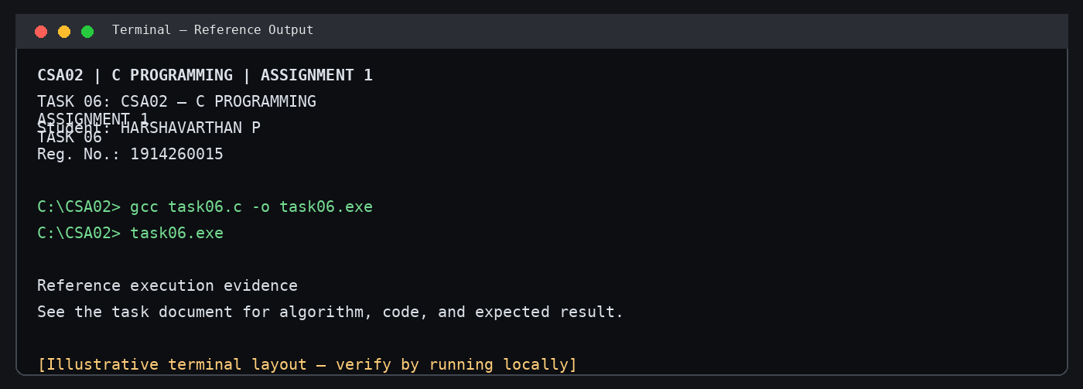
Illustrative terminal-style output screenshot

